Upgrading the performance of district heating networks in Europe
Project No: 785014

Template for the global assessment
of the district heating system
in ____________

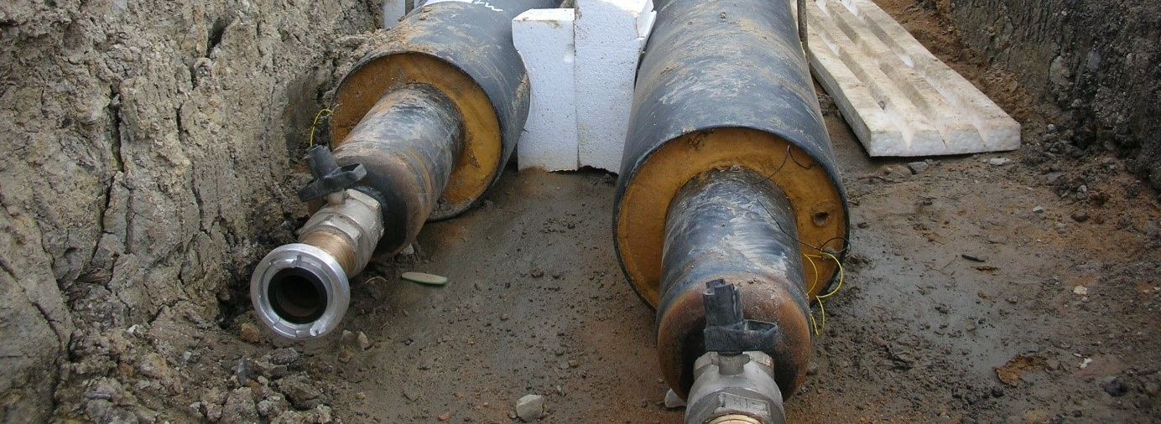

WP 3 – Task 3.2 / D3.2

September 2018

Author of this assessment:
Name: ___________________________________________
Email: ___________________________________________
Company: ___________________________________________

Date: _____________ Place: ____________________

The template for this assessment report is deliverable 3.2 of task 3.2 in the EU Horizon 2020 research project “Upgrade DH”.

The template for this report was created by:  Oliver Miedaner, Solites; Germany  Carlo Winterscheid, Solites, Germany  Sebastian Grimm, AGFW, Germany  Daniel Heiler, AGFW, Germany  Anes Kazagic, EPBiH, Bosnia and Herzegovina | Contact regarding the template:  Steinbeis Research Institute Solites  Carlo Winterscheid  Email: winterscheid@solites.de  Tel: +49 711 673 2000 0  Meitnerstr. 8  70563 Stuttgart, Germany  www.solites.de

This project has received funding from the European Union’s Horizon 2020 research and innovation programme under grant agreement No 785014. The sole responsibility for the content of this report lies with the authors. It does not necessarily reflect the opinion of the European Union nor of the Executive Agency for Small and Medium-sized Enterprises (EASME). Neither the EASME nor the European Commission are responsible for any use that may be made of the information contained therein.

Upgrade DH website: www.upgradedh.eu

Contents

1 Introduction to the global assessment 4
2 Introduction to the district heating system 4
3 General data sheet template 5
3.1 Heat generation 5
3.2 Heat distribution 8
3.3 Heat use 11
4 Interview guideline 13
4.1 First interview with: __________, Date: __________ 13
4.2 Second interview with: __________, Date: __________ 15

Introduction to the global assessment
The aim of the global assessment is to analyse the current situation in a district heating system on technical and non-technical (economics, organization, socio-economics, managerial) circumstances.
Therefore, this template includes:
- General data sheet template for first data collection on technical and non-technical information on the generation, distribution and use of heat at you in a district heating system
(see chapter 3).
- Interview guideline for interviews with stakeholders at a district heating system, e.g. utility, DH network operator, consumer association (see chapter 4).

Introduction to the district heating system

Give a brief introduction to the district heating system (about 1.000 to 2.000 characters).
The aim of the introduction is to give an overview of some basic information (e.g. location of the district heating system, responsible partners) as well as some background information (e.g. ‘history’ of the plant) and information on expectations (e.g. expectation how the district heating system can/ should develop in the near future).

Fill in the introduction …

General data sheet template
Assess in the following the current situation of your district heating system regarding technical and non-technical (economics, organization, socio-economics, managerial) issues, distinguishing between generation, distribution and use of heat.

Heat generation

Table 1: Heat generation – Technical
Technical
Overview | Insert a map with all energy producers (CHP, boilers, etc.) and pumping stations.
Energy carriers and heat generation  (installed capacity in MW_{th/el}) | State the No., age, installed thermal (electric) capacity of each energy source/ power station  Type of source: Combined Heat and Power plant, Boiler, Including excess heat from industries, solar thermal, biomass, biogas, heat pumps, geothermal heat, etc.:  Please add the main used fuel for each source (Coal, oil, gas, biomass, etc.)  State the operation purpose and strategy, e.g. peak load, base load, mid load, heat operated, power operated  - …  - …
Performance  (kWh_{el} / MWh_{th}) | State the performance of the heat supply (additional electrical consumption to operate the system in kWh_{el} per generated heat in MWh_{th}) :  - …
Heat storage  (in m³ an in °C) | State the No., type (water tank pressurized/non-pressurized, pit storage, borehole storage, etc.), purpose (seasonal, weekly, daily, flatten peak load, etc.), size of the heat storage, min. and max. temperature:  - …  - …  Is there a heat pump to discharge the heat storage (e.g. pit storage) to a lower temperature level?  - …
Provision of cold? | ☐ No  ☐ Yes, by: … (e.g. type of chiller, age, capacity, etc.)  If absorption chillers are used, what are the flow and return temperatures? What kind of (re)cooling system is used (wet, dry, hybrid, adiabatic)?
Amount of heat (cold) generated  (in MWh/a) | Primary energy supply: …
Primary energy demand | State the current primary energy demand (Use the calculation method elaborated by OPTIT in Month 3 (Task 4.6)): …
Primary energy factor | State the primary energy factor of the DH network and the calculation method (if applied in your country): …
Fuel supply | State the current fuel supply  (e.g. tons of locally sourced woodchips, liters/tons of imported oil/coal, etc.):  - …  - …
Share of renewables  (in %) | …
GHG emissions  (in t CO₂-equivalent/a) | …
… | …

Table 2: Heat generation – Non-technical (economics, organization, socio-economics, managerial)
Non-technical (economics, organization, socio-economics, managerial)
Type of company | Utility, public, private, etc.  (including the main characterising figures, as No. of employees, annual sales, etc.):  …
Operation | Who specifies how the DH network has to be operated?  …
Maintenance | State the major current regular maintenance activities (equipment repair and overhaul, equipment health monitoring, etc.) and its frequencies (weekly monthly, yearly): …  - …
Costs for maintenance tasks | State the expenses for relevant maintenance tasks:  …
… | …

Heat distribution

Table 3: Heat distribution – Technical
Technical
DH network length  (in km) | Insert a map of your DH network and state the length for main pipes and connecting pipes:  - …  - …
Connected load | How high is the simultaneity factor (network heat input divided by the sum of the connected heat load)?  - …
Age of DH network | …
Type of DH network | Describe the DH network (primary, secondary grid, etc.) and its layout (mesh, star, etc. layout of DH network):  …
Quality of DH network | State information on the quality (pre-insulated pipe; channel type; plastic/ steel jacket pipe; etc.):  …
Temperature levels  (in °C) | Supply / return pipe for winter / summer operation: …
Operation Mode | Constant or gliding (ambient temperature driven) operation: …
Main pipe types/ network characteristics | - Dimension: …  - Pressure: …  - Flow: …  - Heat losses in % (state how calculated) …  - Water losses in % (e.g. number of refills/ re-feedings per year: …
Water quality | State the water quality (conductivity in µS/cm; oxygen, etc.):  …  Are there corrosion problems (inside, outside)?  …  Are there special times, when the network is shut down for repair reasons?  …
No. of connections | …
DH network pumps | State the No., age, installed capacity, etc. of the installed network pumps:  …
Pump regulation | Without regulation, regulated by pressure difference, regulated by index circuit: …  Are there network pumps, operating from different directions into the network?  …  Do you have any data transmission, like differential pressures, temperatures and flows from the network to a central SCADA system?  …
Hydraulics | Does a current hydraulic calculation of the network exist and who is taking care of it?  …
Problems | If there are any problems with the network, what kind of problems are these (static or hydraulic problems, others)?  …
… | …

Table 4: Heat distribution – Non-technical (economics, organization, socio-economics, managerial)
Non-technical (economics, organization, socio-economics, managerial)
Type of company | Cooperative, utility, etc.  (including the main characterising figures, as No. of employees, annual sales, etc.):  …
Documentation | Are site maps available for the DH network?  Information on road, railway, river crossings, etc.:  …
Maintenance | State the current regular maintenance activities (pipe inspection, leakage detection, etc.) and its frequencies (weekly monthly, yearly):  - …  - …
Costs for maintenance tasks | State the expenses for relevant maintenance tasks:  …
… | …

Heat use

Table 5: Heat use – Technical
Technical
Annual heat supply  (in GWh/a) | Amount of heat sold to the customers: …
No. of house substations | State the number of house substations: …
Size of connected customers | State the (average, min. and max.) capacity of the installed heat transfer stations: …
Temperature levels | State the required temperature level (average, min. and max.) of the different customers (design temperatures for radiators/heating systems): …
Type of sub-stations | State the average age, type, etc. of the heat transfer stations: …
Level of digital monitoring | Describe the level of digital monitoring of the connected customers-substations…
… | …

Table 4: Heat use – Non-technical (economics, organization, socio-economics, managerial)
Non-technical (economics, organization, socio-economics, managerial)
No. of customers | …
Type of customers | E.g. Industry, trade and commerce, housing etc.:  …
Heat price  (in €/kW and €/kWh) | State the capacity charge €/kW and energy charge €/kW with and without VAT:  - For private households: …  - For industry: …
Contracts | State the contract duration of the customers:  …
Redensification | Describe your current activities in connecting additional customers to your network in new/ existing areas of the DH network:  …
Return temperatures | Describe your current activities to lower the return temperatures of the customers:  …
… | …

Interview guideline
Perform with stakeholders at your district heating system, e.g. utility, DH network operator, consumer association, etc. interviews according to the following template.

Please fill in the following template for each interview. Feel free to skip not relevant sections and add additional lines for missing topics. Take about 2 to 3 pages per interview.

First interview with: __________, Date: __________

Table 1: First interview
Date/ Time/ Place | State the date, time and place of 1st interview:  …
Interview partner | Name and organization of interview partner:  …
Stakeholder type and sector | Allocate your interview partner to the following options:  ☐ Heat generation: … (e.g. utility)  ☐ Heat distribution: … (e.g. DH network operator)  ☐ Heat use: … (e.g. consumer association, customer)  ☐ Policy  ☐ Other: …
Current technical challenges | Let the interview partner describe technical challenge(s) related to the district heating system. Summarize the findings with about 500 characters. Include in the description when the challenge did occur for the first time and what is the (assumed) reason for it:  ☐ Heat generation:  …  ☐ Heat distribution:  …  ☐ Heat use:  …
Current non-technical challenges | Let the interview partner describe non-technical challenge(s) related to the district heating system. Summarize the findings with about 500 characters. Include in the description when the challenge did occur for the first time and what is the (assumed) reason for it:  ☐ Economical:  …  ☐ Organizational:  …  ☐ Socio-economical:  …  ☐ Managerial:  …
Further questions | State here further questions you have asked and the corresponding answers with maximum 500 characters for each answer:  - …

Second interview with: __________, Date: __________

Continue with the following interviews…

